PROJECT REPORT
Smart Face Attendance and Access Gate System Using Face Recognition and Silicon Labs SiWG917
An AI + IoT Based Automated Attendance and Access-Control Solution
BONAM VENKATA CHALAMAYYA INSTITUTE OF TECHNOLOGY AND SCIENCES DEPARTMENT OF ELECTRONICS AND COMMUNICATION ENGINEERING NAGALLA DURGA PRASAD 24H41A04A9 ROWTHU JAYASREE 24H41A04C0 VAKALAPALLI MEGHNA SRI ADITHYA LAKSHMI 24H41A04C8
Technologies: Python | FastAPI | OpenCV | InsightFace | ONNX Runtime | SQLite | Silicon Labs SiWx917 (BRD2605A)

Smart Face Attendance and Access Gate System Using Face Recognition and Silicon Labs SiWG917

1. Abstract
The Smart Face Attendance and Access Gate System is an IoT-enabled attendance management system that uses face recognition, a web-based dashboard, a local database, Wi-Fi communication, and a Silicon Labs SiWG917/BRD2605A development board to automate student attendance and access indication.
The system allows students to be registered using their identification details and a facial photograph. During live attendance, the laptop webcam captures the student's face and the software extracts a facial embedding using a face-recognition model. The generated embedding is compared with the registered student embeddings stored in the database. When a valid student is recognized, the system records the attendance date, time, and recognition confidence.
The software is implemented using Python, FastAPI, OpenCV, NumPy, SQLAlchemy, SQLite, and InsightFace/ONNX Runtime. A responsive web interface provides student registration, live attendance, dashboard statistics, attendance records, and CSV report generation.
For hardware interaction, the system communicates through Wi-Fi with a Silicon Labs SiWG917-based BRD2605A board. The board runs a lightweight HTTP server and controls an RGB LED. Blue represents the normal/idle state, green represents a recognized/authorized person, and red represents an unknown person or system error. API-key authentication is included to prevent unauthorized control requests.
Thus, the project combines Artificial Intelligence, IoT, embedded systems, wireless communication, and database technologies to provide an automated and scalable attendance and access-control solution.

2. Objective
The main objectives of the project are:
- To develop an automated face-recognition-based attendance system.
- To eliminate the need for manual attendance marking.
- To register students using their student ID, roll number, name, class, section, department, and photograph.
- To identify students using facial embeddings generated from their registered photographs.
- To record the date, time, attendance status, and recognition confidence.
- To ensure that a student receives only one attendance record per day.
- To provide a web-based dashboard for monitoring attendance.
- To connect the attendance software with an IoT-enabled Silicon Labs SiWG917 board.
- To provide visual access/status indication using an RGB LED.
- To provide attendance reports in CSV format.
- To create a low-cost and scalable system suitable for classrooms, laboratories, offices, and controlled-entry environments.

3. Hardware Requirements
The major hardware components used in the combined system are:

3.1 Silicon Labs SiWG917 / BRD2605A Development Board
The SiWG917-based BRD2605A acts as the IoT hardware interface of the project. It provides Wi-Fi connectivity and controls the RGB LED according to commands received from the attendance application.
The firmware implements an HTTP server through which the software can check the board status and control the LED.

3.2 Laptop / Computer
The laptop acts as the main processing unit. It performs:
- Webcam interfacing
- Face detection
- Face embedding generation
- Face recognition
- Database operations
- Web-server operation
- Communication with the SiWG917 board

3.3 Webcam
The webcam captures live images of students during attendance.
The captured frames are processed in memory for recognition and are not permanently stored during normal recognition operation.

3.4 RGB LED
The RGB LED on the Silicon Labs board provides visual status indication:
LED Colour | Meaning
Blue | Normal / Idle state
Green | Recognized / Authorized student
Red | Unknown person / Error condition

3.5 Wi-Fi Network
Wi-Fi provides communication between the computer running the attendance application and the Silicon Labs SiWx917 board.

3.6 USB Cable
A USB connection can be used to program and power the Silicon Labs development board during development and testing.

4. Software Requirements

4.1 Programming Languages
- Python
- HTML
- CSS
- JavaScript

4.2 Backend Technologies
The backend is developed using FastAPI.
FastAPI provides REST API endpoints for:
- Student registration
- Face recognition
- Attendance recording
- Dashboard information
- ESP32/IoT status
- CSV report generation

4.3 Face Recognition
The system is designed around InsightFace and uses facial embeddings for recognition.
The basic process is:
Image → Face Detection → Face Embedding → Similarity Comparison → Student Identification
The system compares the query embedding with the registered embeddings using a similarity score. A configurable matching threshold is used to determine whether the face is recognized.

4.4 OpenCV
OpenCV is used for image processing and decoding the images received from the webcam/web application.

4.5 NumPy
NumPy is used for numerical processing of facial embedding vectors and similarity calculations.

4.6 ONNX Runtime
ONNX Runtime provides the execution environment required for the face-recognition model.

4.7 SQLite Database
SQLite is used as the local database.
The database contains information about:
- Student details
- Facial embeddings
- Student status
- Attendance date
- Attendance time
- Attendance status
- Recognition confidence
A unique constraint is implemented so that the same student cannot receive multiple attendance entries on the same date.

4.8 SQLAlchemy
SQLAlchemy provides database interaction between the Python application and SQLite.

4.9 Silicon Labs Software
The SiWx917 firmware is developed using the Silicon Labs SDK/Simplicity Studio environment and uses Silicon Labs networking and HTTP-server components.
The firmware includes:
- Wi-Fi initialization
- Network connection
- IP-address reporting
- HTTP server
- API-key authentication
- RGB LED control

5. Introduction
Attendance management is an important activity in educational institutions. Traditional attendance systems generally depend on manual calling of student names, signatures, ID cards, or biometric devices. These approaches can consume time and may be vulnerable to proxy attendance or manual errors.
To overcome these limitations, the proposed project introduces face recognition technology into the attendance process.
The system consists of two major sections:

A. Software / AI Section
The laptop runs a local web application. The user can register students by entering their academic details and uploading a photograph. The software processes the photograph and generates a facial embedding.
During live attendance, the webcam continuously provides images to the application. The face-recognition system generates an embedding from the detected face and compares it against the registered student embeddings.
If the similarity exceeds the configured threshold, the student is identified and attendance is recorded.

B. IoT / Hardware Section
After successful recognition, the software can communicate with the connected IoT hardware through Wi-Fi.
The Silicon Labs SiWx917/BRD2605A board operates as an HTTP server. It receives authenticated commands and changes its RGB LED.
The overall status can therefore be represented visually:
Blue → System Ready
Green → Student Recognized
Red → Unknown Person / Error
The system also contains a dashboard that displays the total number of registered students, present students, absent students, and IoT device status.

6. Workflow

6.1 Overall System Workflow
The overall working of the system can be represented as:
Student Registration
↓
Capture / Upload Student Photograph
↓
Face Detection
↓
Generate Facial Embedding
↓
Store Student Details + Embedding in SQLite
↓
Start Live Attendance
↓
Capture Image from Webcam
↓
Detect Face
↓
Generate Query Embedding
↓
Compare with Registered Embeddings
↓
Similarity Score Calculation

If Face is Recognized
Identify Student
↓
Check Today's Attendance
↓
Record Date + Time + Confidence
↓
Send IoT Authorization Command
↓
SiWG917 RGB LED → GREEN

If Face is Not Recognized
Unknown Face
↓
Attendance Not Recorded
↓
IoT Status → RED / No Access Signal

6.2 Student Registration
The administrator enters:
- Student ID
- Roll Number
- Student Name
- Class
- Section
- Department
- Registration Photograph
The backend receives the photograph and processes it using the face-recognition service.
A facial embedding is generated and stored in the database along with the student's information.
The embedding is also loaded into an in-memory cache to make recognition faster.

6.3 Face Recognition
During live attendance, the webcam captures an image.
The image is converted into an OpenCV-compatible format and passed to the face-recognition service.
The system checks:
- Whether a face is present.
- Whether more than one face is present.
- Whether a valid facial embedding can be generated.
- Which registered embedding has the highest similarity.
The similarity is calculated using the normalized embedding vectors.
Conceptually:
Similarity = Query Embedding · Registered Embedding
The highest similarity score is selected. If it is greater than the configured threshold, the student is considered recognized.

6.4 Attendance Recording
After successful recognition, the system checks whether the student has already been marked present on the current date.
The database uses a unique combination of:
Student ID + Attendance Date
This prevents duplicate attendance entries for the same student on the same day.
The attendance record contains:
- Student database ID
- Attendance date
- Attendance time
- Status
- Recognition confidence

6.5 IoT Communication
The backend communicates with the IoT hardware using HTTP over Wi-Fi.
The Silicon Labs firmware provides two important endpoints:

/health
This endpoint is used to check whether the board is online.

/led
This endpoint accepts a colour command such as:
- Red
- Green
- Blue
An API key is required for authenticated access.
The SiWG917 board starts its Wi-Fi interface, obtains its IP address, binds the HTTP server, and waits for incoming commands.

6.6 RGB LED Operation
The RGB LED provides a simple visual representation of the system state.
Normal condition: SiWx917 → BLUE LED
Recognized student: Attendance Software → HTTP Command → SiWx917 → GREEN LED
Unknown/error condition: Attendance Software/Hardware → RED LED
This provides immediate visual feedback without requiring the administrator to continuously monitor the computer screen.

6.7 Dashboard
The web dashboard provides four main sections:

Dashboard
Displays:
- Total students
- Present students
- Absent students
- IoT device status
- Today's attendance information

Live Attendance
Provides:
- Webcam view
- Start scanning
- Stop scanning
- Recognition result

Students
Provides:
- Student registration
- Registered student list
- Student information
- Active/inactive status

Attendance
Provides attendance records and reporting functions.
The system also supports downloading attendance information as a CSV file.

6.8 Data Flow
The combined data flow is:
Student
↓
Webcam
↓
Python / FastAPI
↓
OpenCV
↓
InsightFace / ONNX Runtime
↓
Face Embedding
↓
Similarity Matching
↓
SQLite Database
↓
Attendance Confirmation
↓
Wi-Fi
↓
SiWx917 / BRD2605A
↓
RGB LED Status

7.Output Result

Simplity Studio Console
***************************************
SiWG917 FACE ATTENDANCE APPLICATION
BRD2605A
APPLICATION STARTED
***************************************
RGB LED initialized
NORMAL STATE: BLUE
Initializing Wi-Fi...

event_engine_thread_priority: 50, hal_thread_priority: 49, command_engine_thread_priority: 48
Thread priority order is correct
Wi-Fi interface initialized
Connecting to Wi-Fi...
Wi-Fi connected successfully!

========================================
SiWG917 IPv4 Address: 192.168.2.143
========================================
Binding HTTP server...
HTTP interface bind successful
Initializing HTTP server...

HTTP server initialized
Starting HTTP server...

========================================
HTTP SERVER STARTED
PORT: 80
DEVICE: SiWG917 + BRD2605A
STATUS: ONLINE
========================================
Health:
/health?key=<API_KEY>

LED TEST URLs:
/led?color=red&key=<API_KEY>
/led?color=green&key=<API_KEY>
/led?color=blue&key=<API_KEY>

FACE ATTENDANCE GATE READY

Web Dashboard
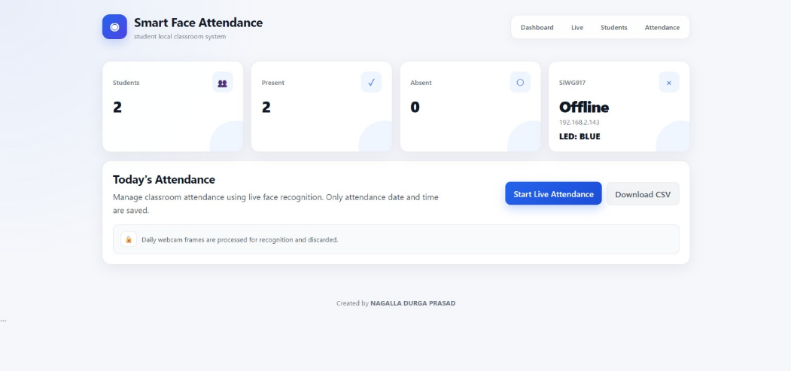

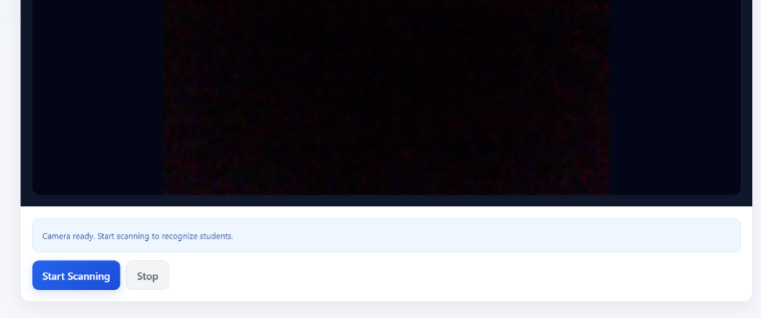
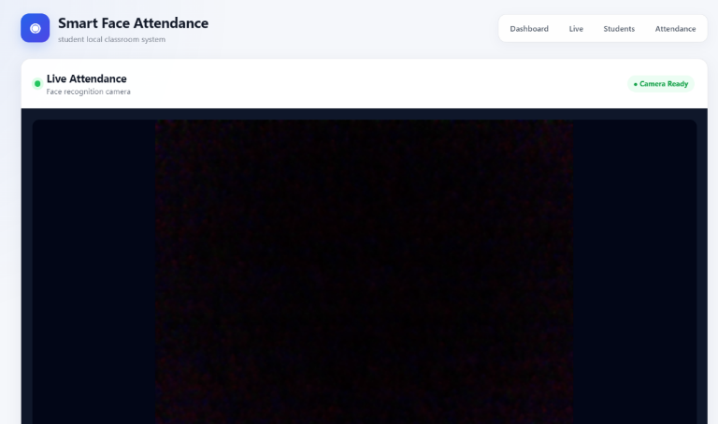
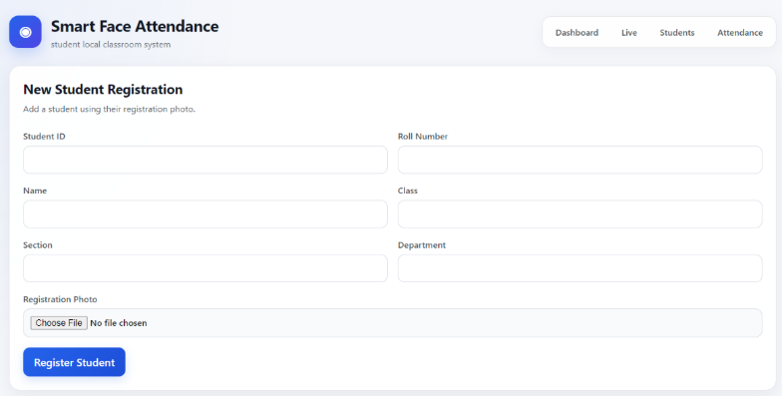
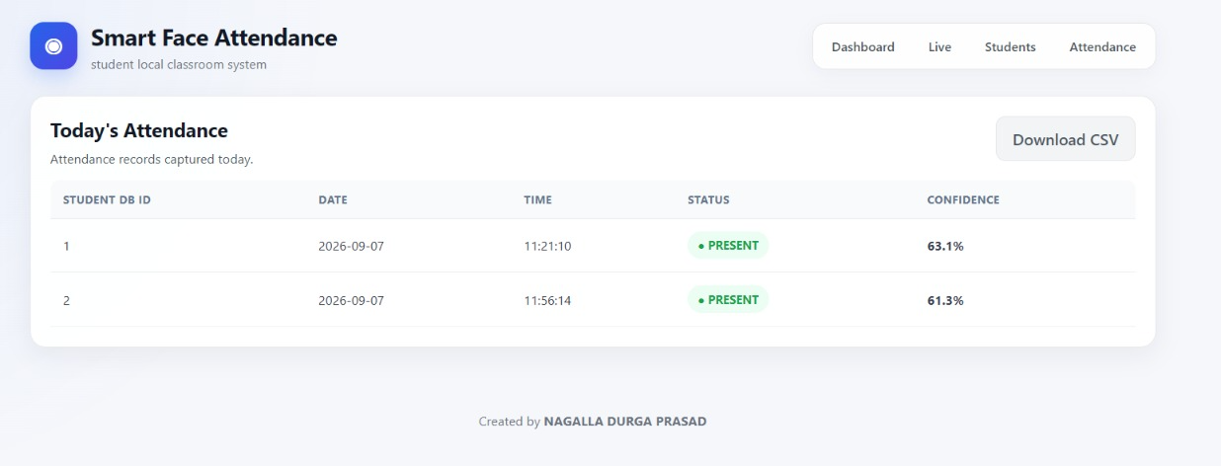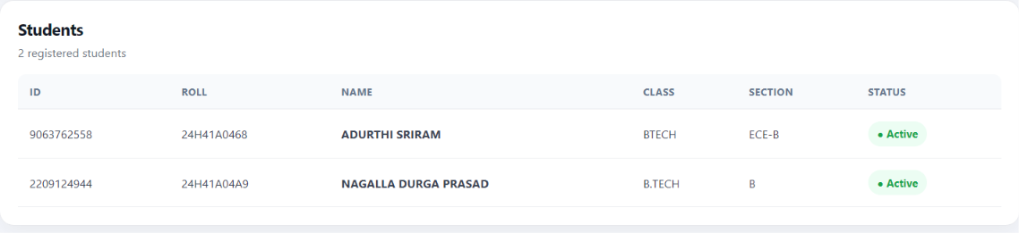

8. Conclusion
The Smart Face Attendance and Access Gate System successfully combines artificial intelligence, IoT, embedded systems, wireless networking, and database technology into a single automated application.
The software component eliminates manual attendance marking by identifying students through facial recognition. Student information and facial embeddings are maintained in a local SQLite database, while attendance is automatically recorded with date, time, status, and confidence information.
The IoT component adds hardware-level interaction to the system. The Silicon Labs SiWG917/BRD2605A connects to the Wi-Fi network and operates an HTTP server. Through authenticated commands, the attendance application can control the RGB LED and provide immediate recognition/status feedback.
The project therefore demonstrates how AI-based identification and IoT-based hardware control can be integrated into an educational automation system.
The architecture can be further expanded to control an actual electronic door or gate, integrate additional security mechanisms, support multiple cameras, and provide centralized attendance management for larger institutions.

9. Applications
The proposed system can be used in several areas:

9.1 Educational Institutions
- Classroom attendance
- Laboratory attendance
- College entry monitoring
- Student access control

9.2 Offices
The system can be used to automatically identify employees and maintain entry/attendance records.

9.3 Laboratories
Only authorized students or staff can be allowed to access restricted laboratories.

9.4 Libraries
Face-based identification can be used for automated entry and attendance monitoring.

9.5 Examination Centres
The system can assist in verifying registered candidates before entering examination areas.

9.6 Hostels
The system can be adapted for hostel entry monitoring and resident identification.

9.7 Smart Access-Control Systems
The IoT hardware can be extended from an RGB LED indicator to:
- Relay modules
- Electronic locks
- Servo motors
- Automatic doors
- Gate controllers

9.8 Smart Campus
Multiple attendance and access-control units can be connected through a common network to create a smart-campus monitoring system.

Summary of the Combined System
The two ZIP projects are combined conceptually as follows:
Face Recognition Software: Webcam → FastAPI → OpenCV → InsightFace → SQLite
IoT Hardware: Wi-Fi → Silicon Labs SiWx917/BRD2605A → HTTP Server → RGB LED
Complete System: Student → Camera → Face Recognition → Attendance Database → Wi-Fi → SiWx917 → RGB LED / Access Indication
This makes the project a Smart AI + IoT Face Attendance and Access Control System rather than simply an attendance application.

